**Argument**

* series of statements in which one statement (the **conclusion**) is meant to follow from or be supported by others (called the **premises**)

**Logically Valid Argument**

* argument is logically valid if and only if the conclusion must be true on the assumption that the premises are true

**Logically Sound Argument**

* if an argument is valid and its premises are true then the argument is **sound**
* a sound argument thus ensures the truth of its conclusion

Logic focuses on the validity of arguments, rather than their soundness. Logic tells you how to reason correctly, given what you know or believe to be true.

**Methods of Proof**

* we will learn fundamental methods of showing when claims follow from other claims and when they do not
* the **main technique for showing that a given conclusion does not follow from some premises** is to find a possible circumstance in which the premises are true but the conclusion is false
* the main technique for showing that a given claim is a logical consequence of some premises is that of a **proof**
* **proof**
  + step-by-step demonstration that a conclusion follows from some premises

**There are four important principles that hold of the identity relation**

1. **Identity Elimination**

* if we can prove, from whatever our premises happen to be, that b=c, then we know that anything that is true of b is also true of c
  + this observation is called **indiscernibility of identicals** or **substitution**
* the formal rule corresponding to this principle is called **Identity Elimination**, abbreviated **= Elim**
* This principle of identity elimination is used all the time in mathematics when we substitute an expression for another expression that it is equal to
  + x^2>x^2-1
  + x^2>(x-1)(x+1)
  + we eliminated the identity x^2-1=(x-1)(x+1)

1. **Reflexivity of Identity**

* formal rule: **Identity Introduction, = Intro**, allows us to introduce identity statements into proofs
* any sentence of the form a=a can be validly inferred from whatever premises are at hand, or from no premises at all
  + this is because of the assumption in FOL that each name refers to exactly one object (which isn’t true in English, for example)

1. **Symmetry of Identity**

* allows us to conclude b=a from a=b

1. **Transitivity of Identity**

* a=b, b=c then a=c

**Formal Proofs**

* deductive system: system for presenting formal proofs
  + come in different styles
  + we will present one particular style, the “Fitch-style” system
  + it was introduced first by Frederic Fitch
  + later we will look at the resolution method, a different deductive system

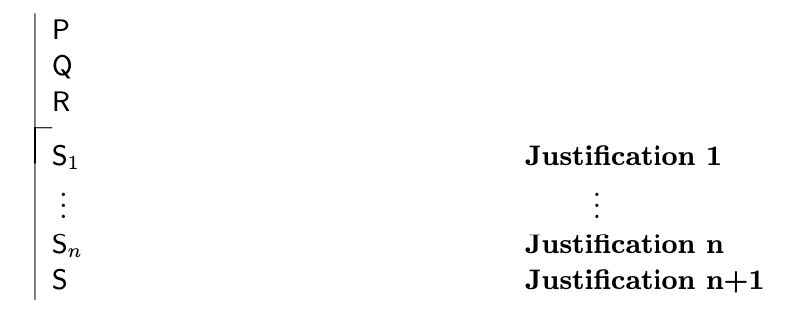

* a **justification** indicates which rule allows us to make the step, and which earlier steps (if any) the rule is applied to
* **example**

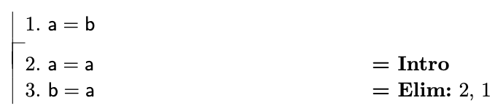

**Here are our rules so far presented formally**

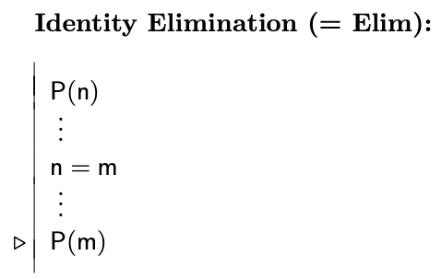

* P(n) is a sentence containing n
* Applying the Identity Elimination rule means that we have proven a P(n) and a sentence n=m, and that we are then justified in asserting any sentence which results from P(n) by replacing some or all occurrences of n by m

**Ana Con (Analytic Mechanism)**

* mechanism that, among other things, lets you check for consequences among atomic sentences that involve many of the predicates in the blocks language world
* not restricted to atomic sentences
* **allows you to cite some sentences in support of a claim if any world that makes the cited sentences true also makes the conclusion true, given the meaning of the predicates as used in Tarski’s World**
* technically, not really a rule
  + Fitch behind the scenes tries to find proofs of the claim based on the cited sentences; many, many rules may be applied in this proof
  + Fitch may fail to find a proof, even if there is one

**Demonstrating Nonconsequence**

* **There are different varieties of proofs**
* **Proof of consequence**
  + proof that a particular piece of information must be true if the given information, the premises of an argument, are correct
* **Proof of Nonconsequence**
  + different kind of proof
  + “defense attorney shows that the crime might have been committed by someone other than the client”, ie attorney is trying to prove that the client’s guilt does not follow from the evidence in the case
* An argument is valid if every possible circumstance that makes the premises true also makes the conclusion true
* An argument is invalid if there is **some circumstance that makes the premises true but the conclusion is false**
  + **Finding such a circumstance** is the key to **demonstrating nonconsequence**
  + Such as circumstance is said to be a **counterexample** to the argument
  + Anything that clearly shows the existence of a counterexample is fair game
* Are there such things as formal proofs of nonconsequence, similar to the formal proofs of validity constructed in F? In general no.